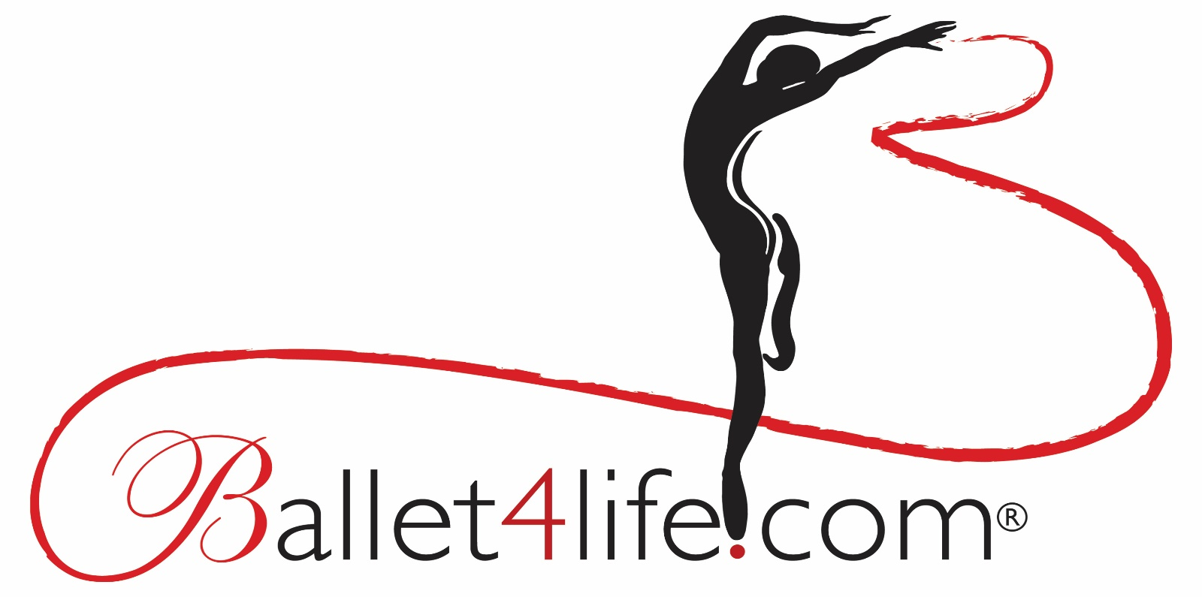

Established in 2004

Ballet4life- Celebrating Dance Day 2020

29 April 2020 from London, UK

Five live-stream dance classes as part of our extensive online dance programme

Times are BST

10 30am- General Level Ballet with Mark Kelly

11.45am- Centre Floor Ballet Exercises with Donna Schoenherr

12.30pm- Contemporary Dance Warm-up with Chris Christodoulou

3pm- Beginner Ballet Barre with Johanna Saarinen

6pm- Beginner Improver Ballet with Alina Luts.

These classes are suitable for adults sixteen years of age and up. There is no upper age limit. We specialise in teaching dance to adult learners. These classes are open to the public, but a registration form needs to be completed first by emailing us at ballet4lifeuk1@gmail.com. Once the form is completed and returned Ballet4life sends the login details, and general guideline. The timetable for the online programme which continues indefinitely is www.ballet4life.com/timetables. The classes are free of charge with a kind request for a small donation if at all possible.

www.ballet4life.com - website

ballet4lifeuk1@gmail.com -email

https://www.facebook.com/ballet4life.uk/ - Facebook

@ballet4lifeuk – Twitter, Instagram, Pinterest

